Hub Switch Router

How Hub works?
The hub works on layer 1 of the OSI reference model. It is a dumb device. It has no intelligence to decide how to send information from a particular source to a specific destination. The data is broadcasted over the network across all its ports except the one on which it was received. The communication is, therefore, not secure. The network may also experience congestion and collisions.
Hubs are of 3 types:
- Passive Hubs: These hubs just send the signal to all devices without amplification.
- Active Hubs: These hubs amplify the signals before sending it to all devices.
- Intelligent Hubs: These hubs provide additional features such as management and remote monitoring but again work in layer 1, so very limited feature.

What is a Switch?
A network switch Layer 2 (Data Link Layer) is a networking device that connects multiple devices within the same local network (LAN) and forwards data intelligently using packet switching. It is an improved and more efficient version of a hub.

How Switch works?
It is an intelligent device that can decide to send information from a particular source to a destination based on MAC addresses. The switch builds a MAC address table along with the port number for all of the devices that are connected to the switch. It then uses it to forward frames from a particular source to the destination. The communication is, therefore, unicast once the switch has learned the MAC address of the destination device. The communication is, therefore, secure.
Switch can be classified in two categories, which are:
- Unmanaged Switches: These are simple switches having no configuration options. They are mainly used in small home networks where advanced controls are not required.
- Managed Switches: Managed Switches are advanced switches that come with configuration options, such as traffic control, security features, VLANs, Traffic control (QoS), Port security and network monitoring. These are used in enterprise-level networks.

Working Procedure of a Network Switch (Step-by-Step)

Step 1: Frame Arrives at a Port
- A device sends Ethernet data (frame) to the switch by physical port and the switch checks the frame for errors (FCS)

Step 2: Source MAC Learning
- The switch reads the Source MAC Address
- Stores it in the MAC Address Table (CAM Table)
Format:
- Source MAC → Incoming Port
This helps the switch remember where each device is connected

Step 3: Destination MAC Lookup
- The switch reads the Destination MAC Address
- Searches the MAC table
Three possible cases occur here:

Case 1: Destination MAC Found (Unicast)
- Switch knows the destination port, Forwards the frame only to that port, Other ports do not receive the data

Case 2: Destination MAC Not Found (Unknown Unicast)
- Switch does not know where the destination is, Floods the frame to all ports (except source port), Destination replies, Switch learns the destination MAC for future use

Case 3: Broadcast or Multicast
- Broadcast (FF:FF:FF:FF:FF:FF) is sent to all ports in the VLAN
- Multicast is sent to group member ports only

Step 4: Frame Forwarding Method
Switch uses one of these internal methods:
- Store-and-Forward — Receives entire frame, checks errors, then forwards (most common)
- Cut-Through — Starts forwarding after reading destination MAC (very fast)

Step 5: Queueing and Scheduling
- If multiple frames want the same output port:
  - Frames are placed in buffers
  - Switch schedules transmission
- QoS may prioritize voice or video traffic

Step 6: Transmission to Destination
- Frame exits through the selected port
- Destination device receives the data
- Communication completes

Step 7: MAC Table Aging
- If a device is inactive:
  - Its MAC entry is removed after a timeout (default ~300 seconds)
  - Keeps the table updated automatically

Simple Flow Summary
- Receive frame
- Learn source MAC
- Check destination MAC
- Decide forwarding action
- Queue if needed
- Send frame
- Update MAC table

A CAM (Content Addressable Memory) table is a fast memory table inside a switch that stores:
- MAC Address
- Port of Switch
- VLAN ID (in managed switches)
- Timestamp (aging time)
Aging time is the time period a switch keeps a learned MAC address in its MAC (CAM) table when no traffic is seen from that device. Generally 300 seconds (5 minutes)
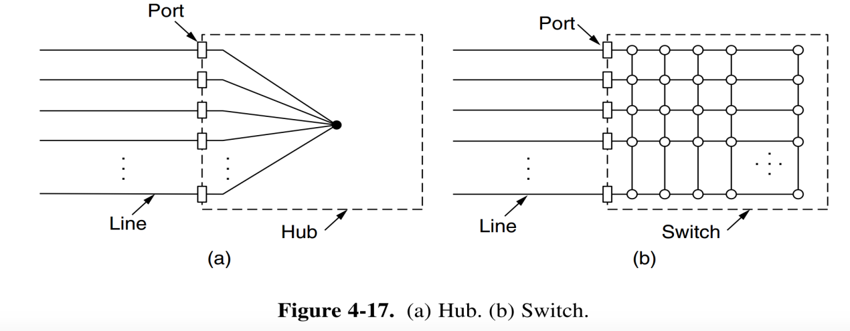

What is Router?
A network router is a layer 3 networking device used to connect multiple different networks together. It is commonly used as a gateway to connect a local network (LAN) to another network such as the Internet (WAN).

How Router works?
It is an intelligent device that can decide to send information from a particular source to the destination network based on the IP address allocated to each networked device. The router creates a routing table, which it then utilizes to transmit packets from one source to another. It also performs decision-making for best path or route to reach a specified destination network address.
There are three types of routers:
- Wired Routers: These routers connect various devices via Ethernet cable. So, they are less flexible but very fast.
- Wireless Routers: These devices allow devices to connect wirelessly. It includes Wi-Fi, access points, etc.
- Core Routers: These routers are used in large networks, such as ISPs and Data Centers, for directing data within the network.

Router in Computer Networks — Complete Detailed Explanation
A router is one of the most important devices in networking. It is responsible for connecting different networks and deciding the best path for data to travel between them.
Below is a full, structured, exam-ready explanation covering almost everything about routers.

How a Router Works

Step 1: Packet Arrival
- A data packet arrives at a router interface
- The packet contains: Source IP and Destination IP

Step 2: Destination IP Check
- Router reads the destination IP address but Ignores MAC addresses for routing decisions

Step 3: Routing Table Lookup
- Router checks its routing table
- Finds the best matching network (longest prefix match), /24 is more specific than /16 ip address.
- Longest Prefix Match means a router always chooses the route with the most specific (correctness) subnet mask that matches the destination IP address.

Step 4: Path Selection (Chooses the best route based on)
- Metric (measure path cost)
- Administrative distance (AD, how trustworthy the route source is, lower is better)
- Routing protocol rules (how metrics are calculated and accepted, RIP(distance vector), OSPF, EIGRP, BGP)

Step 5: Forwarding
- Router forwards the packet to:
  - Next-hop router (next-hop IP address from the routing table) or
  - Directly connected destination network

Routing Table
A routing table is the router's decision database.
It contains:
- Destination network
- Subnet mask
- Next hop
- Outgoing interface
- Metric

NAT (Network Address Translation)
- Converts private IP to public IP
- Common in home and campus routers

DHCP (Optional)
- Assigns IP addresses automatically

